Wish List Application

Description

User Stories
Login & authentication
- As a user, I want to create an account with secured authentication so that my login credentials are safe, and I can access my unique wish list account.
- As a user, I want to I want to login into my unique account given my login info so that I can access my personal wish list account.
- As a user, I want to be able to sign out of my account so that someone else can log into the same application through a different account.
View landing page & web components
- As a user, upon login, I want to see various components of the application so I that I know where to navigate throughout the application.
- As a user, upon login, I want to see a home page that welcomes me and provides a brief description with instructions on how to navigate/use the wish list application so I know how to use the app.
- As a user, I want to see a nav bar so that I can see my options and see each component within the application.
- As a user, I want a dashboard so that all of my wish lists are located in one organized location in the application.
- As a user, I want a live countdown so that I can view the precise time until Christmas starts.
Create & manage wish lists
- As a user, I want to create and name as many wish lists I want, so that I can begin adding items my lists.
- As a user, I want to add, update, and delete items on my wish list so that I can change my wish list based on my evolving interests.
- As a user, I want to be able to update and delete my wish lists so that I have more control over managing my wish lists.
- As a user, I want to view my wish lists so I can know what items and lists are currently being managed.

ER Diagram
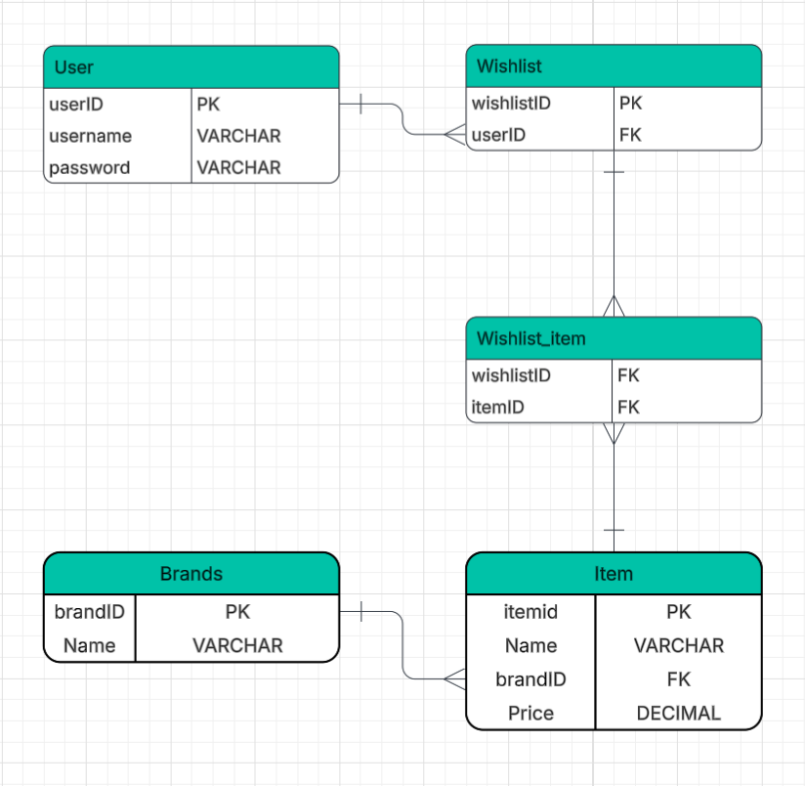

Endpoints

Wire Frame

Tasks:
Java/Spring
Model - status
Repository - status
Service - status
DTO - status
Controllers - status
Testing - TODO
Angular
Components
Testing - TODO

